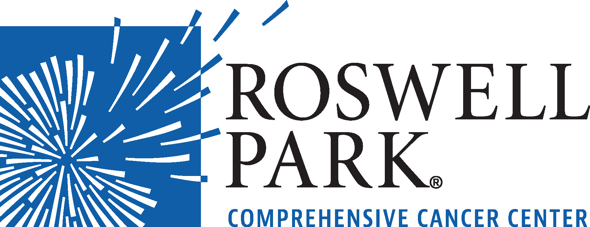 | FOR IMMEDIATE RELEASE  July 11, 2022  Contact: Annie Deck-Miller, Roswell Park  716-845-8593; annie.deck-miller@roswellpark.org

– MEETING NOTICE –

WHAT: Special Board of Directors Meeting
Roswell Park Comprehensive Cancer Center
WHEN Monday, July 18, 2022
10:00 a.m.

WHERE Scott Bieler Clinical Sciences Center
9th Floor Patrick P. Lee Board Room

Click here to join meeting: https://www.roswellpark.org/boardofdirectorsmeeting

Roswell Park Comprehensive Cancer Center is a community united by the drive to eliminate cancer’s grip on humanity by unlocking its secrets through personalized approaches and unleashing the healing power of hope. Founded by Dr. Roswell Park in 1898, it is the only National Cancer Institute-designated comprehensive cancer center in Upstate New York. Learn more at www.roswellpark.org, or contact us at 1-800-ROSWELL (1-800-767-9355) or ASKRoswell@roswellpark.org.

