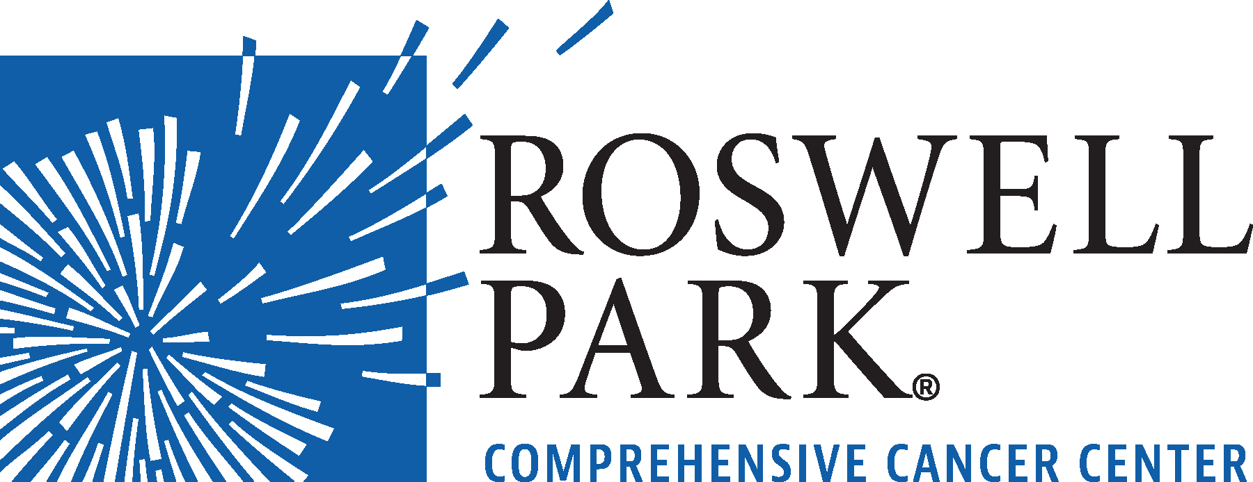 | FOR IMMEDIATE RELEASE  September 16, 2026  Contact: Annie Deck-Miller, Roswell Park  716-845-8593; annie.deck-miller@roswellpark.org

– MEETING NOTICE –

WHAT: Roswell Park Comprehensive Cancer Center’s Board of Directors Meeting
Roswell Park Comprehensive Cancer Center
WHEN Wednesday, September 23, 2026
12:00 Noon

WHERE Roswell Park Comprehensive Cancer Center
Research Studies Center
Gaylord Conference Room
Elm & Virginia Street
Buffalo, NY 14263
###
Click here to join meeting: https://www.roswellpark.org/boardofdirectorsmeeting

From the world’s first chemotherapy research to the PSA prostate cancer biomarker, Roswell Park Comprehensive Cancer Center generates innovations that shape how cancer is detected, treated and prevented worldwide. Driven to eliminate cancer’s grip on humanity, the Roswell Park team of 4,000 makes compassionate, patient-centered cancer care and services accessible across New York State and beyond. Founded in 1898, Roswell Park was among the first three cancer centers nationwide to become a National Cancer Institute-designated comprehensive cancer center and is the only one to hold this designation in Upstate New York. To learn more about Roswell Park Comprehensive Cancer Center and the Roswell Park Care Network, visit www.roswellpark.org, call 1-800-ROSWELL (1-800-767-9355) or email ASKRoswell@RoswellPark.org.

