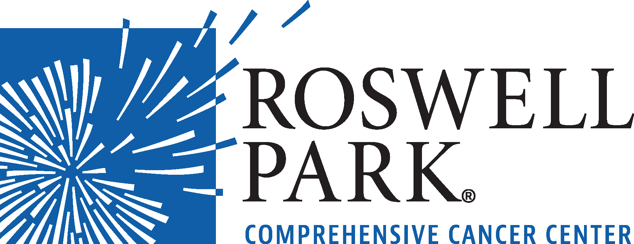 | FOR IMMEDIATE RELEASE  Monday, February 1, 2021  Contact: Annie Deck-Miller, Roswell Park  716-845-8593; annie.deck-miller@roswellpark.org

– VIDEO CONFERENCE MEETING NOTICE –

WHAT: Merit Board Meeting
Roswell Park Comprehensive Cancer Center
WHEN: Monday, February 8, 2021
8:30 a.m.

Video Conference Link: www.roswellpark.org/meritboardmeeting

###
Roswell Park Comprehensive Cancer Center is a community united by the drive to eliminate cancer’s grip on humanity by unlocking its secrets through personalized approaches and unleashing the healing power of hope. Founded by Dr. Roswell Park in 1898, it is the only National Cancer Institute-designated comprehensive cancer center in Upstate New York. Learn more at www.roswellpark.org, or contact us at 1-800-ROSWELL (1-800-767-9355) or ASKRoswell@RoswellPark.org.

