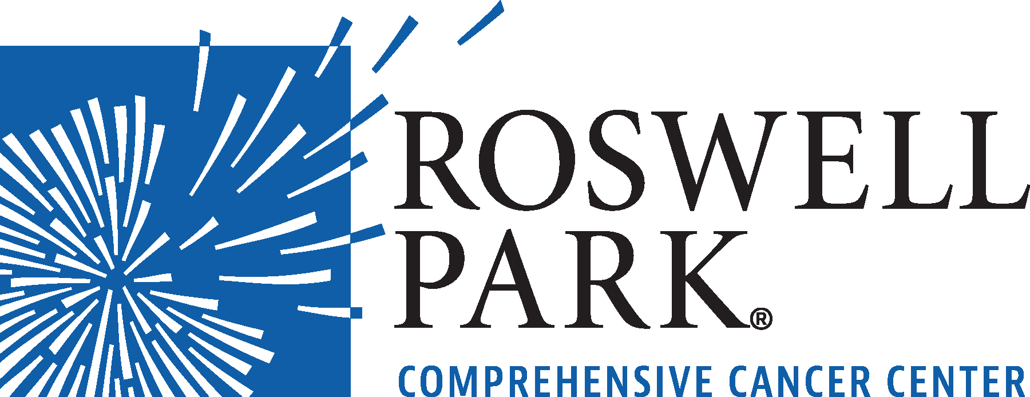 | FOR IMMEDIATE RELEASE  June 9, 2021  Contact: Annie Deck-Miller, Roswell Park  716-845-8593; annie.deck-miller@roswellpark.org

– MEETING NOTICE –

WHAT: Board of Directors Meeting
Roswell Park Comprehensive Cancer Center
WHEN Thursday, June 17, 2021
12:00 Noon

WHERE Roswell Park Comprehensive Cancer Center
Center for Genetics and Pharmacology
Zebro Family Conference Room
Buffalo, NY 14263
###
Roswell Park Comprehensive Cancer Center is a community united by the drive to eliminate cancer’s grip on humanity by unlocking its secrets through personalized approaches and unleashing the healing power of hope. Founded by Dr. Roswell Park in 1898, it is the only National Cancer Institute-designated comprehensive cancer center in Upstate New York. Learn more at www.roswellpark.org, or contact us at 1-800-ROSWELL (1-800-767-9355) or ASKRoswell@roswellpark.org.

