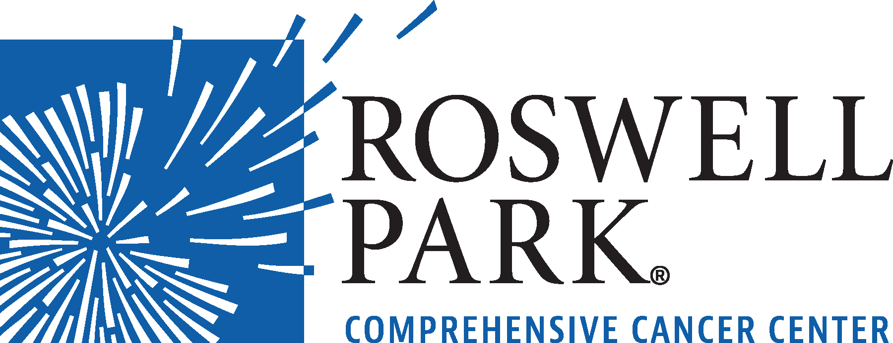 | FOR IMMEDIATE RELEASE  September 9, 2026  Contact: Annie Deck-Miller, Roswell Park  716-845-8593; annie.deck-miller@roswellpark.org

– MEETING NOTICE –

WHAT: Finance Committee Meeting
Roswell Park Comprehensive Cancer Center
WHEN Wednesday, September 16, 2026
8:30 a.m.

WHERE Roswell Park Comprehensive Cancer Center
Scott Bieler Clinical Sciences Center
9th Floor, Patrick P. Lee Board Room
Buffalo, NY 14263

Click here to join meeting: https://www.roswellpark.org/financemeeting
Copies of non-confidential meeting material may be obtained for a copying fee by calling 716.845.4994 or emailing betsy.doty@roswellpark.org. Requests for copies should be made not later than twenty-four (24) hours prior to the meeting.
From the world’s first chemotherapy research to the PSA prostate cancer biomarker, Roswell Park Comprehensive Cancer Center generates innovations that shape how cancer is detected, treated and prevented worldwide. Driven to eliminate cancer’s grip on humanity, the Roswell Park team of 4,000 makes compassionate, patient-centered cancer care and services accessible across New York State and beyond. Founded in 1898, Roswell Park was among the first three cancer centers nationwide to become a National Cancer Institute-designated comprehensive cancer center and is the only one to hold this designation in Upstate New York. To learn more about Roswell Park Comprehensive Cancer Center and the Roswell Park Care Network, visit www.roswellpark.org, call 1-800-ROSWELL (1-800-767-9355) or email ASKRoswell@RoswellPark.org.

