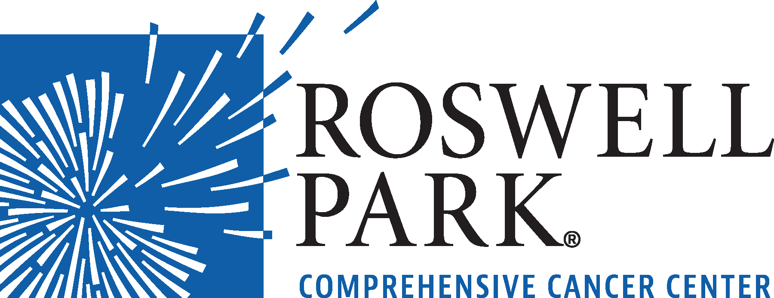 | FOR IMMEDIATE RELEASE  June 19, 2018  Contact: Annie Deck-Miller, Roswell Park  716-845-8593; annie.deck-miller@roswellpark.org

– MEETING NOTICE –

WHAT: Compensation Committee Meeting
Roswell Park Comprehensive Cancer Center

WHEN: Wednesday, June 27, 2018
10:30 a.m.

WHERE: Roswell Park Comprehensive Cancer Center
Scott Bieler Clinical Sciences Center
Patrick Lee Conference Room
Elm & Carlton Streets
Buffalo, NY 14263
###
Roswell Park Comprehensive Cancer Center is a community united by the drive to eliminate cancer’s grip on humanity by unlocking its secrets through personalized approaches and unleashing the healing power of hope. Founded by Dr. Roswell Park in 1898, it is the only National Cancer Institute-designated comprehensive cancer center in Upstate New York. Learn more at www.roswellpark.org, or contact us at 1-800-ROSWELL (1-800-767-9355) or ASKRoswell@roswellpark.org.

