Wednesday, June 8th, 2022 | Ostomy News  Latest news and bulletin updates |  |  |  | Issue # 5
Wound Ostomy Continence Nursing Department  Updates and Changes  - Say hello to our Team. We are here to help.  - Keeping Connected:  Ostomy Support Group flyer added to the “Upcoming Events” electronic board in the patient waiting rooms and Outpatient Pharmacy in addition opreviously mentions vehicles of communication.  - Reminders: Please sign in with any updates to your contact information and pick up a new flyer for today’s meeting. |  |  | 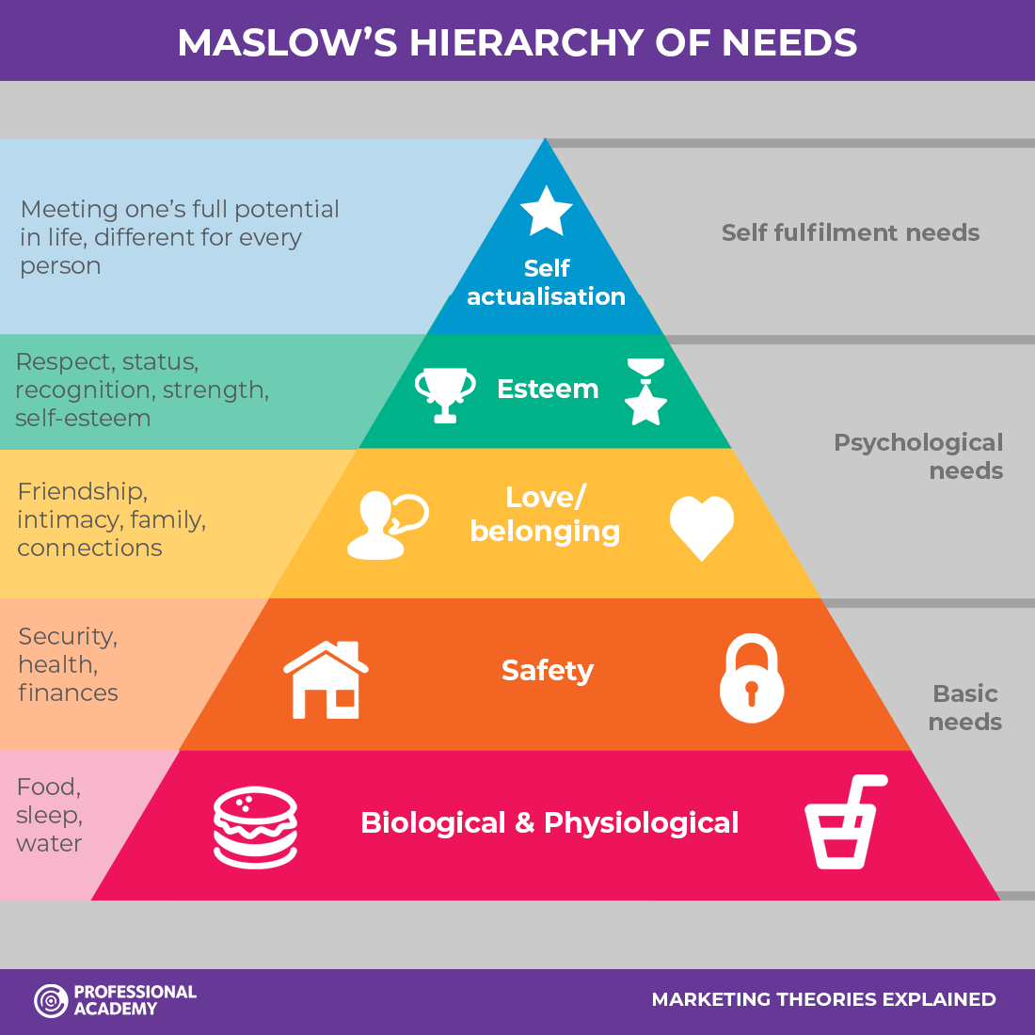
- “Love and Belonging” is the third benchmark in Maslow’s Hierarchy of Needs.

Topic of the Day: Intimacy Post Ostomy Creation

- Basic Needs are addressed during post-operative admission and readmission.
- Speaking about intimate relationships is difficult for many to address with their healthcare providers. We have brought the conversation to you
- Please welcome Dr. Tova Ablove, Urogynecologist, UBMD Obstetrics & Gynecology, Female Pelvic Medicine & Reconstructive Surgery Specialist, Clinical Associate Professor at Jacobs School of Medicine and Miomedical Sciences, University at Buffalo.

