Wednesday, April 13th 2022 | Ostomy News  Latest news and bulletin updates  Let’s Get Physical … |  |  | Issue # 4
Wound Ostomy Continence Nursing Department  Updates and Changes  - Say Hello to Our Team. We are here to help!  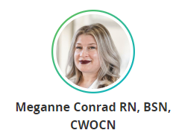  - Keeping connected:  Check the Roswell Park Ostomy Support Group Website, 1st Floor Cafeteria Billboard, your e-mail, and/or the Ground Floor Billboard by the main elevators for updates through the year.  - Attendance:  Don’t forget to sign in and provide your e-mail if you haven’t already.  - New Flyers  Please pick up a new Flyer for updated dates and location! |  |  | 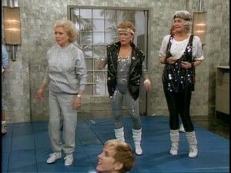  Physical Therapy!
Discussion Topic of the Day:
Incorporating Physical Therapy for a healthy core and lifestyle.
 |  |  | Spring has sprung! With fresh air, warmer temperatures, and more sunshine comes the need for gardening, lawncare, and some therapeutic walks to take in season, just to name a few. Roswell’s Physical Therapy Team is a perfect resource for keeping your core strength a priority so you can enjoy the things that matter most to you.

