SOP for Retrovirus Production using HEK293T cells

Materials
1.) HEK293T cells

2.) Plasmid DNA for:
a.) plasmid of interest
b.) pCL-ampho (for amphotropic virus) or
c.) pCL-eco (for ecotropic virus)

3.) Transfection reagent (FuGENE 6, Lipofectamine 2000, etc.)

Procedure
Note: I use lipoD293 at a 1:2.5 DNA to lipo ratio. The following protocol has been optimized for lipoD293 transfection in a 6 cm dish. The procedure may differ slightly with different transfection reagents.

1 day before transfection:

1.) Split 293T cells into culture dishes at ~80% confluence. Be sure cells are evenly distributed throughout the plate. Clumps will reduce transfection efficiency.

2.) Incubate for next 24 hours undisturbed at 37ºC and 5% C02.

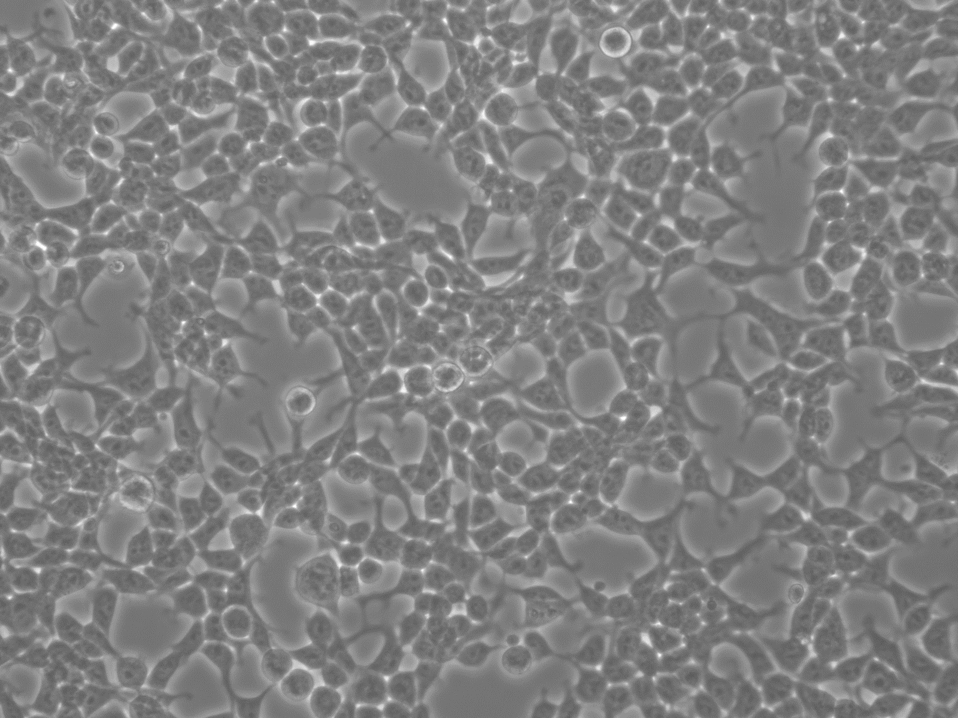 This is about the confluency I’m shooting for at the time of transfection. Too sparse and the VSV-G will be very toxic. Too dense and the media will yellow quickly and the pH will be too low.

Day of transfection:

Follow transfection protocol for the reagent you are using or use the following protocol for lipoD293 reagent.

1.) Add 2.5ug plasmid DNA from your construct, 2.5ug of the pcl plasmid (eco or ampho – depending on desired tropism) to 250ul DMEM (no serum or antibiotics)

2.) Add 12.5 ul lipoD293 (1 : 2.5 DNA to lipoD ratio) to 250ul DMEM (no serum or antibiotics)

3.) Combine the tubes from steps 1 and 2 and gently flick to mix the contents. Incubate the combined mixture at room temperature for 15 minutes.

4.) Aspirate media from 293T cells and carefully add the 500ul DNA / Lipo complex to the dish.
Note: 293T cells detach very easily from the plate. Take care in adding the complex mix.

5.) Swirl the plate very gently to mix. Incubate a few minutes (~2-3 min.) at room temperature and then very carefully add 2.5mls normal 293T media (DMEM media supplemented with 10%FBS and 1% Pen/Strep) to cells.

6.) Incubate the cells 4-6 hours at 37ºC and 5% C02. ** If your transfer vector has GFP, you should be able to see it by 6 hours.

7.) Change the media to fresh DMEM media supplemented with 10% FBS and 1% Pen/Strep. Incubate an additional 48 hrs. at 37ºC / 5% CO2 (or at 32° for greater virus stability.)

** Incubate the plate O/N at 37°c as viral packaging/production is reported to be more efficient at 37°c. However, lentivirus has a half-life of only 8-9 hours at 37 degrees. It’s better to move transfected cells to 32°c after 18hrs or so and them keep at 32°c while collecting the media.

Note: 293T cells can detach easily from the plate and you do not want to disturb them, particularly at this point. Add the fresh media carefully.

Day 3 (48 hours) after transfection:

1.) Collect virus-containing supernatant and store virus overnight at 4°c

** Also, avoid letting the media turn yellow. At the lower pH virions are highly unstable. I sometimes add HEPES buffer prior to harvesting to help the pH stay stable and keep your virions happy.

2.) Add another 3.0 – 3.5ml of fresh DMEM media supplemented with 10% FBS and 1% Pen/Strep to the cells (and HEPES). Incubate the cells overnight at 37ºC / 5% CO2 (or at 32° for greater virus stability.)

Note: I have found that there is very little difference in viral titer at 48hrs vs. 72hrs. However, if I’m not collecting virus for 72hrs I will definitely incubate cells at 32°c for the last 24 hrs. The half-life is much longer at 32°c!

Day 4 (72 hours) after transfection:

1.) Collect virus-containing supernatant and combine with 48hr supernatant.

Remove any cells from harvested medium by filtration through 0.45 µm (**Lentiviruses and retrovirus can both be partially retained in 0.22 um filters, thus use 0.45 um filters to remove any contaminating cells) cellulose acetate (low protein binding) syringe filter. This is the viral stock.

Note: Virus can be used directly to infect target cells, or stored at 4°c for use within a week. For longer term storage virus can be stored at -70°c. Titer will decrease 2-3 fold with each freeze / thaw so immediate use is recommended.

2.) Discard the 293T cells.

